*Core Java - Introduction Assignment*

**Instructions:**

Below you will find a series of assignments that you will complete in this exercise. You will need to create a new project folder for this task and name it **Java_Assignment_1_Introduction**. You can use the default settings when creating the new project.

For each of the below assignments you will create a new class as specified below and write your code in a **main()** method of that class. You can use the same (default) package when creating each class.

**Assignments**

1. Write a class named **Assignment1** in which you print the message “Hello, World!” to the console
2. Write a class named **Assignment2** in which you declare a variable, x. In the next line, set the value of x to 5. Print the value of x to the console.
3. Write a class named **Assignment3** in which you declare the variables, x and y. Set the value of x to 15 and set the value of y to 10. Create a third variable, z and assign the result of the sum of x and y to z. Print the value of z to the console.
4. Write a class named **Assignment4** in which you declare an array of 5 numbers. Print its length to the console. (Use the .length property)
5. Write a class named **Assignment5** in which you declare an array of ten strings. Print the 2nd element. (Remember that arrays indexes start at 0, not 1).
6. Write a class named **Assignment6** that declares an array of two numbers (10.5 and 11.5). Add the two numbers together and print the result.
7. Write a class named **Assignment7** that declares an array of three numbers (11, 22, 33). Subtract the first two and add the third; (11- 22 + 33). Print the result.
8. Write a class named **Assignment8**, that declares two floats (105.678 and 222.4871). Multiply them and print the result.
9. Write a class named **Assignment9** that declares a boolean variable on. Set its value to true. Print the result.
10. Write a class named **Assignment10** that declares an array of five strings. Print the 5th element.

**Goal:**

The purpose of this assignment is to provide you practice with writing simple classes. You will utilize the **main()** method of your classes to execute a particular goal of the assignment. You will also gain experience writing print messages to the console as well as performing simple arithmetic operations and using arrays.

By the end of this assignment, you will have 1 new project folder with 10 classes that meet the requirements mentioned above.

**Helpful Notes**

Project Structure:

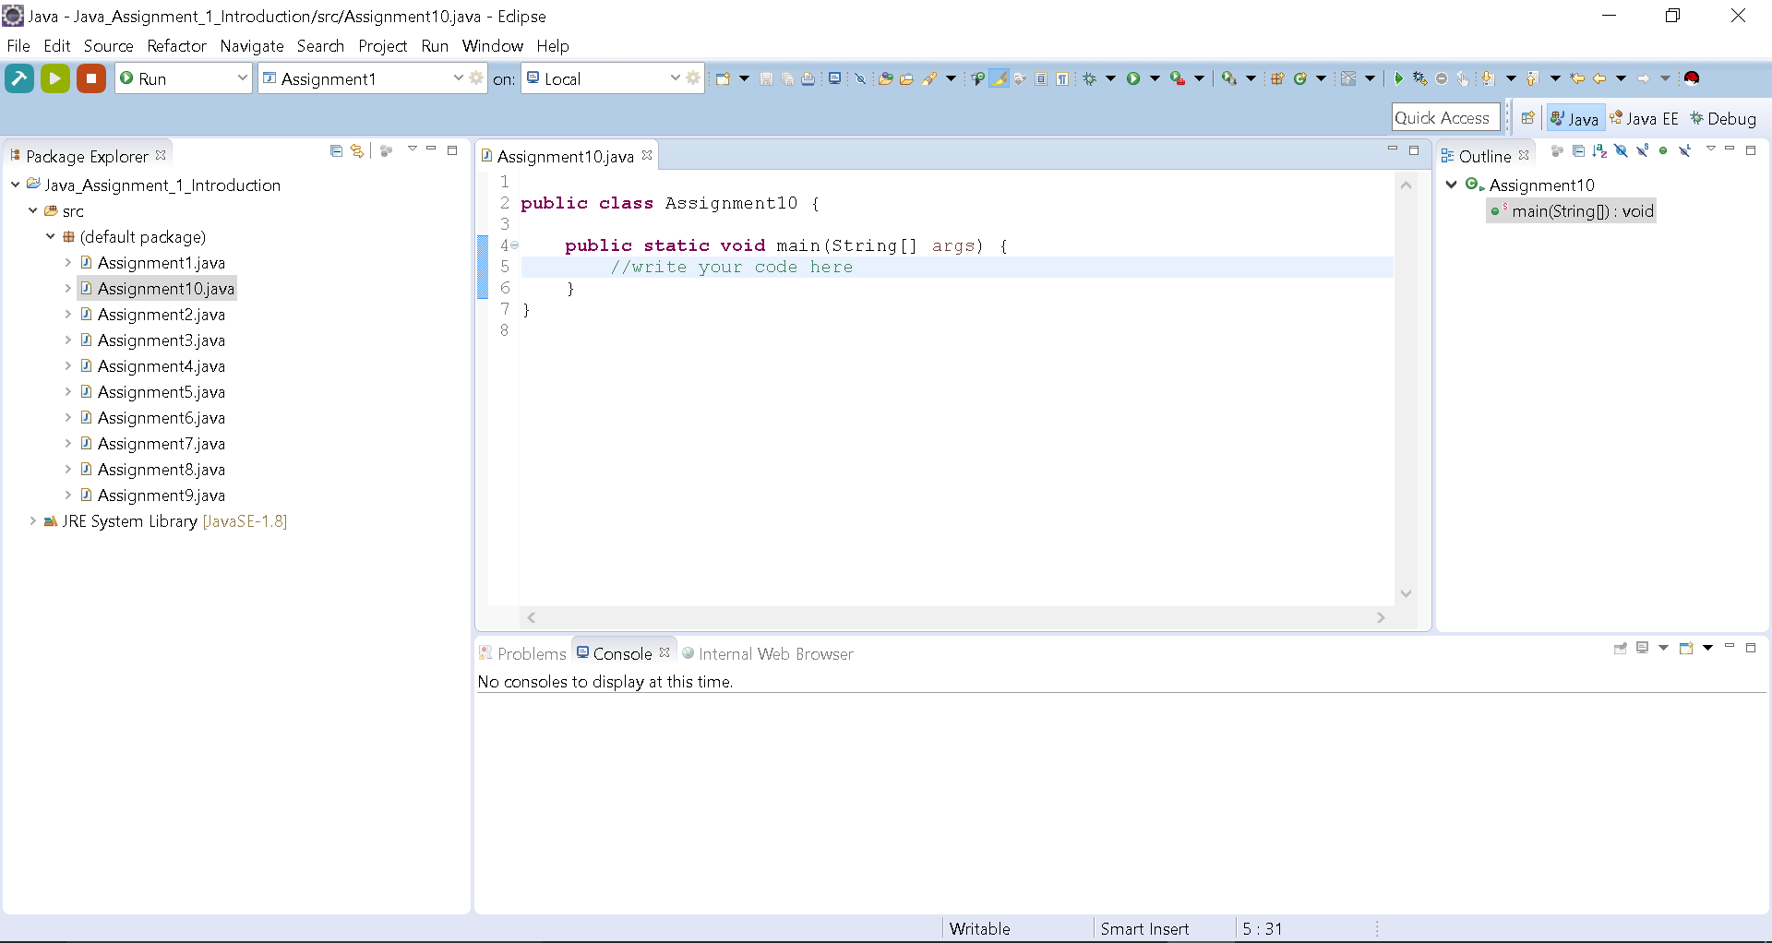

* Your project structure should resemble the above. Note that the name of the project is **Java_Assignment_1_Introduction** and all class files are named according to the associated assigned number

Assignment Classes:

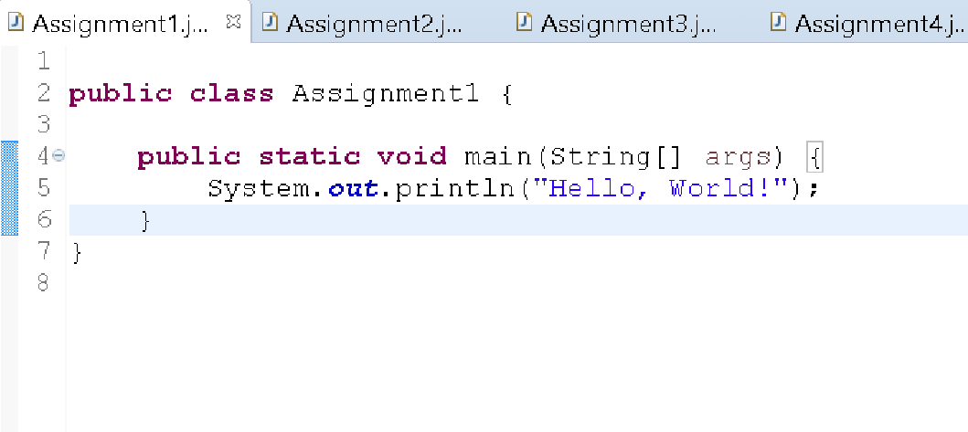

* Notice the indentation of the statement on line 5 to show that it is part of the main() method. Likewise, your code should follow this pattern.